Release Notes
Importing partner data from Central Statistical Office (CSO)

Revision history:
Name | Date | Reason for change | Version
Abul Hassan | 27.05.2014 | Created Release Notes | 1.0

Document Conventions
NIP Number stands for VAT Number in ERP (field „vat” in res.partner object).
REGON Number is the number given by CSO – it isn't commonly used in invoices – it may be used but it's not obligatory.

Purpose
This document provides the release description of the "Importing partner data from Central Statistical Office (lacan_cso)" OpenERP module.

Release History

Version 1.0 – 27th May 2014
This is the first release of the product for LT QC process.

What’s new in this release?
This is the first release. Features as explained in TD are covered. Some features which are ommitted from the initial BRD are covered under Limitations. Summary of the features in this release.
- Installing this module helps the user to pull company information directly from the CSO website using the VAT / PESEL number.
- A new button is added to the "Partner" form. While adding/editing a partner information, clicking this button will launch a wizard. This wizard will show the "VAT/PESEL" Number and the Captcha Image from the CSO website. User inputs the information & submits the information to the server.
- The user is redirected to another screen where the user can choose to update the existing address with the information obtained from CSO website.

Known Issues
There are no known issues at this moment.
Issue ID | Priority | Status | Issue Summary

Limitations
- Initial BRD requested for a means to check if the address has changed when the user fills out the invoice. This requirement is not covered and ommitted during the TD phase because of the way the application is implemented.
- If there is a change in the CSO website (URL or HTML content change), then most likely this application would fail.
- If the NIP validation passed and if still the NIP is not available in the CSO website, the application may throw an error saying CAPTCHA is wrong as there is no way as of now to find out if the captcha or NIP is wrong. But this is highly unlikely or very rare to occur.

Usage Instructions
- When creating / modifying a partner (Menu: Sales → Address Book → Customers) enter the VAT/PESEL number of the partner in the "VAT" field as shown in the picture a1.47_lacan_account_gus_picture_1
- Click on the button "Fetch data from CSO" also shown in a1.47_lacan_account_gus_picture_1
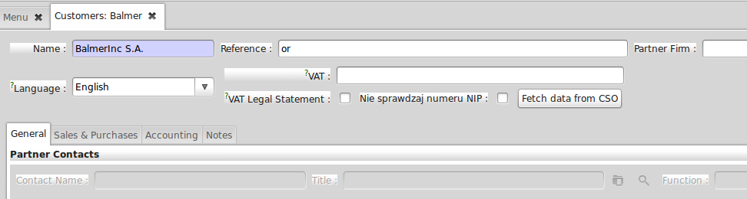
a1.47_lacan_account_gus_picture_1

- Upon clicking, the button in previous step, system shows a wizard as shown in picture a1.47_lacan_account_gus_picture_2
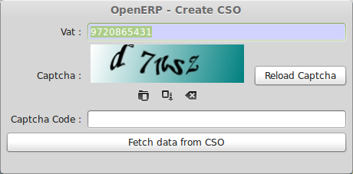
a1.47_lacan_account_gus_picture_2
- The entered VAT/PESEL number is shown along with a Captcha image from the CSO website. If required, the VAT/PESEL number can be edited. If the Captcha is not clear, the "Reload Captcha" button helps to reload a new Captcha from the CSO website.

- Click on the "Fetch data from CSO".
- If the captcha and the VAT/PESEL is correct, then the system shows the next screen as shown in a1.47_lacan_account_gus_picture_3. Else an error saying the captcha or VAT/PESEL is wrong is shown.
- System shows a confirmation box to update the address with the address information obtained from CSO website. A relevant address based on the information obtained from the CSO website is already loaded in to the "Select Address to Update" if a relevant address is available and if modifying an existing partner. Else, the field is empty. A new address can be created or one can be picked from existing address list by clicking the "Search" icon.
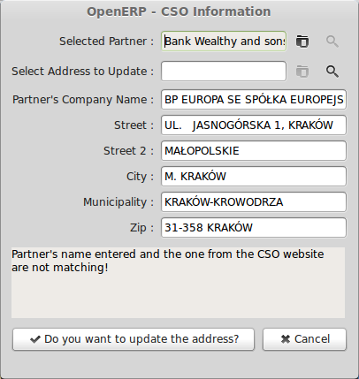
a1.47_lacan_account_gus_picture_3
- The information presented can be edited if required. Click on the "Do you want to update the address" button to "Update" the selected address with the one in the wizard.

